**TESTING FUNCTIONS WRITTEN IN CODE**

1. Input decoding function:

**def** decode_options(self, option, prev_option):

All inputs need to be Integer values in the range of 1 to 5 as we have a State Machine with 5 states at each level.

If the user enters a valid value on the console, the input function decodes the values by checking for the corresponding key:value in the dictionary (all_possible_moves)

Screenshots of different value testing:

**Input**: 1

Expected Output: Based on the previous state, value entered and the corresponding value in the dict: Go to Winterfell

Evidence:

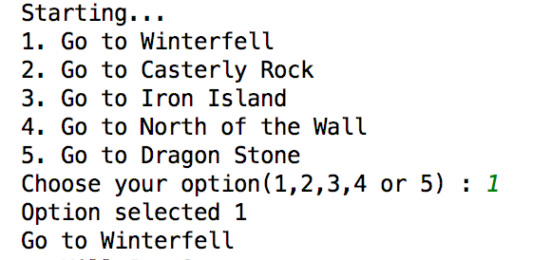

**Input**: No input passed

**Expected Output:** Error Message and Ask the User to Retry

Evidence

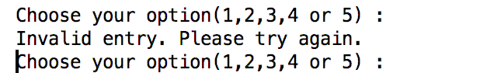

**Input:** Any value other than 1,2,3,4 and 5 (E.g.: 6)

**Expected Output:** Error Message and Ask the User to Retry

Evidence

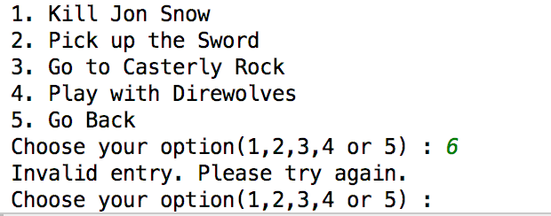

**Input:** Junk characters (E.g: ,.,.,/.,;)

Expected Output: Error Message and Ask the User to Retry

Evidence

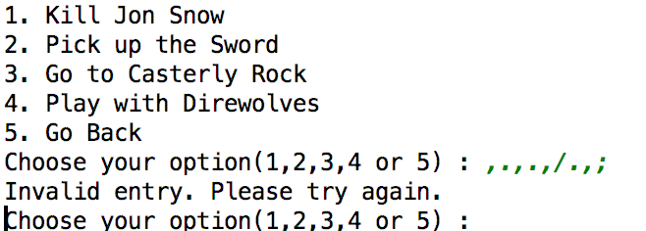

**Input:** String (E.g.: Vivek)

Expected Output: Error Message and Ask the User to Retry

Evidence

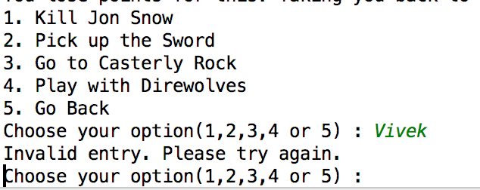

1. Play GOT Theme music in the background

**def** play_got_music(self):

Input: No input

Expected Output: Play GOT music in the background of the game 11 times (Have set this loop count a)

Evidence: Will show during code review

1. Show the background story on the screen before the game begins

**def** disp_background_story(self):

Input: No input

Expected Output: Background story of the game to be shown on the screen

Evidence

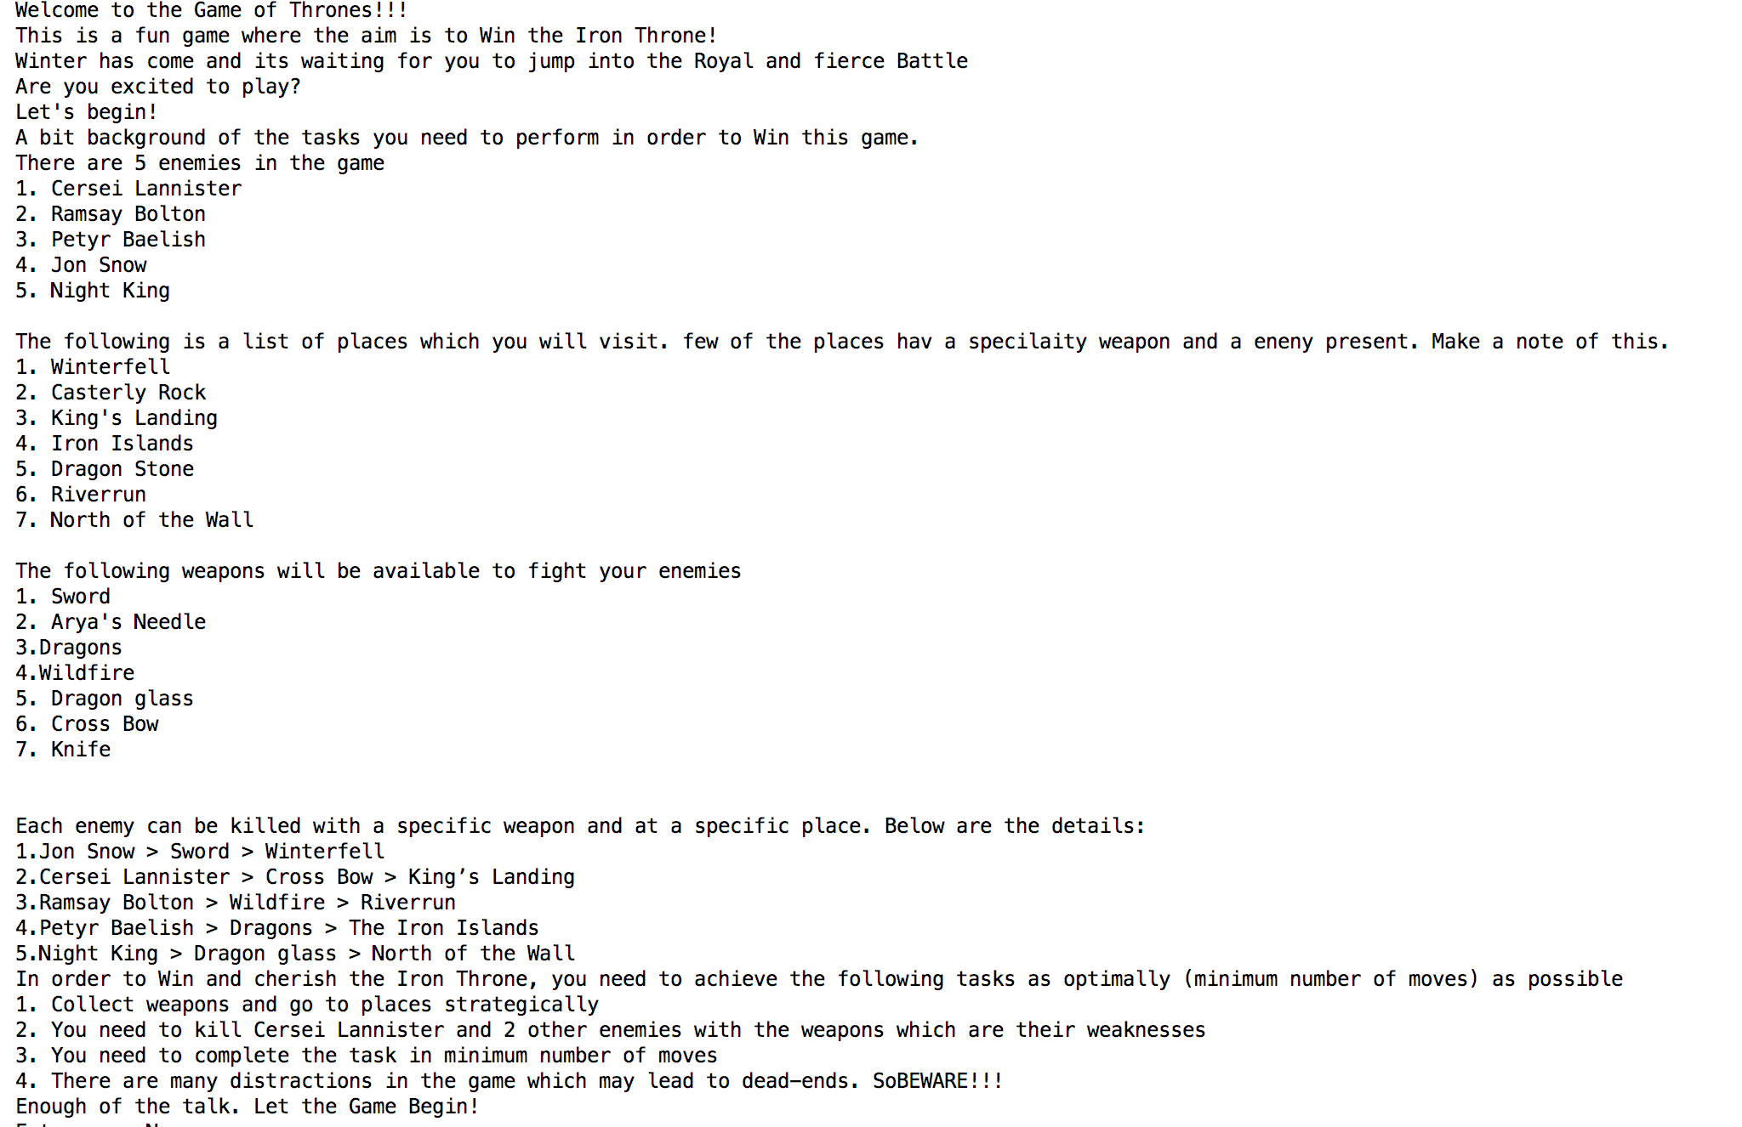

1. Score calculation function

All the input variables are managed by the code and don’t depend on the user or any external dependency. Segregated this code snippet from the main function for code readability and modularity.

def calcuate_score(self, game_finished_flg, num_of_moves, wrong_input_count, wrong_kill_count, enemy_killed_count):

1. Save stats function

All the input variables are managed by the code and don’t depend on the user or any external dependency. Segregated this code snippet from the main function for code readability and modularity.

def save_stats_to_file(self, player_name, game_finished_flg, num_of_moves, wrong_input_count, wrong_kill_count, enemy_killed_count, score):

1. Save States function

All the input variables are managed by the code and don’t depend on the user or any external dependency. Segregated this code snippet from the main function for code readability and modularity.

def save_states(self, player_name, options_selected):